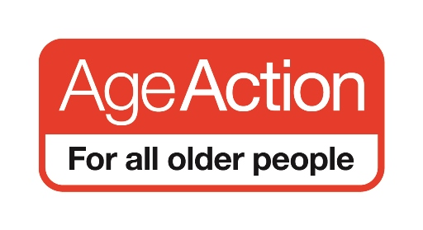

Submission to the Tenth Open-Ended Working Group on Ageing: Education, training, life-long learning and capacity-building

January 2018

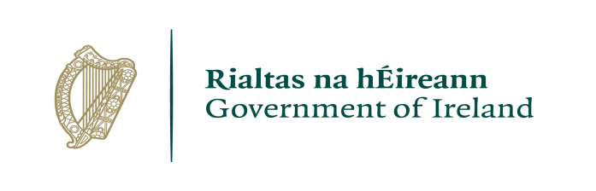 | 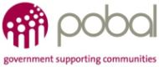
The Scheme to Support National Organisations is funded by the Government of Ireland through the Department of Rural and Community Development

Age Action is the leading advocacy organisation on ageing and older people in Ireland. Our mission is to achieve fundamental change in the lives of all older people by eliminating age discrimination, promoting positive ageing and securing their access to comprehensive and high-quality services that meets their needs.
We want to make Ireland the best country in the world in which to grow old and we work with older people to build a society free of ageism where their rights are secured.
A central feature of our work is raising awareness about the lived experience of growing old in Ireland.

National Legal Framework

In your country/region, how is the right to education, training, life-long learning and capacity building in older age guaranteed in legal and policy frameworks?

In Ireland there is a notable absence of legislative or policy frameworks for the question areas for those over 65 years of age. Social isolation and loneliness can have a substantial negative effect on older people’s quality of life. Currently, those over 64 years of age are not included in the national strategy of the Department of Education and Skills. This results in a significant cohort of the Irish population being excluded from learning measures. An OECD Adult Skills Survey conducted with the Central Statistics Office (CSO) in Ireland interviewed 6,000 people aged 16 – 65 and assessed their literacy, numeracy and ability to use technology to solve problems and accomplish tasks. The study found that adults aged 25 – 34 have the highest literacy mean score in Ireland while adults aged 55 – 65 have the lowest mean score. The highest problem-solving mean score in Ireland is achieved by those in the 20 – 24 age group, while the lowest is achieved by those aged 60 – 65. It is worth noting that over 65’s were not included in the study.

A number of key national education and training strategies have been developed by the Irish Government to drive the significant changes that are being planned and implemented across the continuum of education. These include:
- National Skills Strategy 2025
- National Strategy on Literacy and Numeracy for Learning and Life 2011-2020
- Further Education and Training Strategy 2014 – 2019
- National Strategy for Higher Education to 2030
- National Strategy on Education for Sustainable Development in Ireland, 2014-2020

Of note, those over 64 years of age are either excluded or not identified as a specific cohort in the above listed policies.

The European Commission’s Lifelong Learning Programme 2014-2020 recognises that lifelong learning is a form of community education that provides opportunities for people of all ages and backgrounds to learn together within their community. It has set a target of 15 per cent participation rate in lifelong learning programmes for the EU by 2020.

Learning throughout a life cycle delivers a wide range of positive outcomes for individuals, communities and society empowering people to be engaged learners and active citizens.

Ireland has a lifelong learning target for participation rates of 10 per cent by 2020, and 15 per cent by 2025, as detailed in the Action Plan for Education 2016-2019. The most recent analysis of participation rates in lifelong learning in Ireland showed us at almost half the EU average for those over 55 years: 3 per cent for Ireland versus 6 per cent for the EU average.

Ireland’s position in the overall ranking of EU member states by lifelong learning participation fell by four places from 2012 to 2016, to 20th position out of all 28 states. Of interest, the most recent analysis shows a decrease in participation rates in lifelong learning except for the unemployed and those over 55 years.

There are some special administrative provisions in place for older jobseekers. These provisions aim to help people during the transition from the labour force into retirement. These provisions recognise that older jobseekers may have more difficulty re-training and re-entering the workplace if they lose their job when they are near to retirement age. Older people in some cases have to retire at 65 but they may not qualify for a State pension until they are 66.

Availability, Accessibility and Adaptability

What are the key issues and challenges faced by older persons in your country/region with regard to the enjoyment of all levels of quality education, training, life-long learning, and capacity building services?

Digital literacy levels in Ireland among older people lag behind the EU average and far behind comparable EU neighbours. Digital literacy is one of the key barriers in terms of capacity to access education and training in public provided services. For example, half of Irish people aged between 65 and 74 have never used the internet. The National Digital Strategy describes internet use among those aged over 75 as negligible. The definition of ‘literacy’ today includes being able to use simple, every day, technology to communicate and handle information. Literacy issues around technology exclude a large group of people in society from educational, financial and commercial opportunities.

What steps have been taken to ensure that education, training, life-long learning, and capacity building services are available and accessible to all older persons, adapted to their needs, suited to their preferences and motivations, and of high quality?

Since 2008 the Department of Communications, Climate Action and Environment has consecutively run two programmes designed to increase digital literacy:

- The BenefIT Programme, which ran to the middle of 2016, provided more than 160,000 training places over its lifetime at a cost of €8.4 million.
- This was replaced by the Digital Skills for Citizens Grant Scheme, which allocated €2.2 million for 2016/2017 to 15 community and not-for-profit organisations to provide 10 hours of free computer training to people across Ireland.

While this training is open to anyone who has not previously used the internet, it is
specifically targeted at “people over 45, farming communities, small business owners, the unemployed, persons with disabilities and disadvantaged groups.”

Both programmes have been successful in encouraging older people to get online. However, there is no funding to allow an older person to repeat classes to cement learning and build up confidence. This can be important when a period of ill health means a substantial amount of time passes between classes.

In your country/region, are there studies and/or data available on the access of older persons to the right to education, training, life-long learning and capacity building in older age?

The absence of national level policies on education, training, life-long learning and capacity building that specifically identifies older people as a target results in a data deficit regarding their needs and level of participation in the areas of question. That said, a 2016 study revealed that in total, 11% of people aged 50-64 and 4.3% aged 65+ participate in informal education in Ireland.

Equality and non-discrimination

In your country, is age one of the prohibited grounds for discrimination in relation to education in older age?

Two pieces of legislation prohibit discrimination on the basis of age regarding education in Ireland. The Equal Status Acts 2000-2015 makes it unlawful for educational establishments in Ireland to discriminate on any of the nine grounds, including age. This legislation applies to public and private pre-school services, primary or secondary schools, and institutions which provide continuing or third level education.

It is unlawful for any educational establishment to discriminate on the basis of age with regard to admission, access to any course, facility or benefit, other terms of participation or sanctions against a student. The Employment Equality Acts 1998-2015 provide for similar protections regarding vocational training.

Certain exemptions on the grounds of age are provided for under these Acts, such as provisions to treat mature students differently to encourage participation e.g. to offer easier requirements for continuing or third level education for mature students than for those attending directly from second level education.

Accountability

What mechanisms are necessary, or already in place, for older persons to lodge complaints and seek redress for denial of their right to education, training, lifelong learning and capacity building?

A complaint regarding discrimination on age grounds covered by the terms of the Equal Status Acts 2000 – 2015 or the Employment Equality Acts 1998-2015, can be made to the Workplace Relations Commission.

National Adult Literacy Agency Adult Skills Survey (2012) available at https://www.nala.ie/sites/default/files/content-page/attachments/piaac_factsheet_2013.pdf
Department of Education and Skills Action Plan for Education (2016 – 2019) available at https://www.education.ie/en/Publications/Corporate-Reports/Strategy-Statement/Department-of-Education-and-Skills-Strategy-Statement-2016-2019.pdf
Expert Group on Future Skills Needs (2017). Lifelong Learning Report 2017. Available at www.skillsireland.ie.
The most recent year of data available.
The State Pension age in Ireland is due to increase to aged 67 in 2021 and aged 68 in 2028.
Department of Communications Climate Action and Energy Doing More with Digital National Digital Strategy (2013) available at https://www.dccae.gov.ie/en-ie/communications/publications/Documents/63/National%20Digital%20Strategy%20July%202013%20compressed.pdf
Response to Parliamentary Question 3195/17 on 24 January 2017
Response to Parliamentary Question 9078/17 on 22 February 2017
Age Action’s Getting Started Programme has been a recipient of Government funding under both programmes.
https://www.dccae.gov.ie/documents/DCCAE%20Getting%20Citizens%20Online%20Programme.PDF
Positive Ageing 2016 National Indicators Report available at https://health.gov.ie/wp-content/uploads/2016/11/Positive-Ageing-Report-Nov-2016.pdf
See https://www.ihrec.ie/your-rights/i-have-an-issue-with-a-service/i-have-an-issue-about-education/.
See www.ihrec.ie and www.workplacerelations.ie.

